**1NAME** :- Manish Shashikant Jadhav

**UID** :- 2023301005.

**BRANCH** :- Comps -B. **BRANCH:** B.

**EXPERIMENT 9:** Implement Hashing using Quadratic Probing.

**SUBJECT** :- DS (DATA STRUCTURES).

**CODE** :-

#include <stdbool.h>

#include <stdio.h>

#include <stdlib.h>

#include <string.h>

#define TABLE_SIZE 23

typedef struct KeyValue {

    char *key;

    char *value;

    bool isDeleted;

} KeyValue;

typedef struct {

    KeyValue **array;

    int size;

    float load_factor;

    int num_keys;

    int num_occupied_indices;

    int num_ops;

} HashTable;

KeyValue *createKeyValue(char *key, char *value) {

    KeyValue *newKeyValue = (KeyValue *)malloc(sizeof(KeyValue));

    if (newKeyValue != NULL) {

        newKeyValue->key = strdup(key);

        newKeyValue->value = strdup(value);

        newKeyValue->isDeleted = false;

    }

    return newKeyValue;

}

HashTable *createHashTable() {

    HashTable *newTable = (HashTable *)malloc(sizeof(HashTable));

    newTable->array = (KeyValue **)malloc(TABLE_SIZE * sizeof(KeyValue *));

    for (int i = 0; i < TABLE_SIZE; i++)

        newTable->array[i] = NULL;

    newTable->size = TABLE_SIZE;

    newTable->load_factor = 0;

    newTable->num_keys = 0;

    newTable->num_occupied_indices = 0;

    newTable->num_ops = 0;

    return newTable;

}

int key_to_int(char *key) {

    int sum = 0;

    int index = 0;

    while (*key) {

        sum += (*key) * (index + 1);

        key++;

        index++;

    }

    return sum;

}

int hash_function(char *key, int size) {

    return key_to_int(key) % size;

}

int insert_key_value(HashTable *ht, char *key, char *value) {

    if (ht == NULL || key == NULL || value == NULL)

        return -1;

    int index = hash_function(key, ht->size);

    int original_index = index;

    int i = 1; // Quadratic Probing Counter

    while (ht->array[index] != NULL) {

        if (strcmp(ht->array[index]->key, key) == 0 && !ht->array[index]->isDeleted)

            return -1; // Similar Key

        index = (original_index + i * i) % ht->size;

        i++;

        // Table Traversed Completely or Not

        if (index == original_index)

            return -1; // Table Failed

    }

    // Insert the key-value pair

    ht->array[index] = createKeyValue(key, value);

    ht->num_keys++;

    ht->num_occupied_indices++;

    ht->num_ops++;

    return index;

}

char *search_key(HashTable *ht, char *key) {

    if (ht == NULL || key == NULL)

        return NULL;

    int index = hash_function(key, ht->size);

    int original_index = index;

    int i = 1; // Quadratic Probing Counter

    while (ht->array[index] != NULL) {

        if (strcmp(ht->array[index]->key, key) == 0 && !ht->array[index]->isDeleted) {

            return ht->array[index]->value;

        }

        index = (original_index + i * i) % ht->size;

        i++;

        // Table Traversed Completely or Not

        if (index == original_index)

            break;

    }

    return NULL; // Key not found

}

int delete_key(HashTable *ht, char *key) {

    if (ht == NULL || key == NULL)

        return -1;

    int index = hash_function(key, ht->size);

    int original_index = index;

    // Quadratic probing to handle collisions

    while (ht->array[index] != NULL) {

        if (strcmp(ht->array[index]->key, key) == 0 && !ht->array[index]->isDeleted) {

            // Mark it Deleted

            ht->array[index]->isDeleted = true;

            ht->num_keys--;

            ht->num_ops++;

            return index;

        }

        index = (index + 1) % ht->size;

        // Table Traversed Completely or Not

        if (index == original_index)

            break;

    }

    return -1; // Key not found

}

int get_load_factor(HashTable *ht) {

    if (ht == NULL || ht->size == 0)

        return -1;

    return (float)ht->num_keys / ht->size;

}

int get_avg_probes(HashTable *ht) {

    if (ht == NULL || ht->num_ops == 0)

        return -1;

    return ht->num_ops / ht->num_keys;

}

void display(HashTable *ht) {

    if (ht == NULL)

        return;

    printf("Hash Table:\n");

    printf("| %-10s | %-15s | %-15s |\n", "Index", "Key", "Value");

    printf("|------------|-----------------|-----------------|\n");

    for (int i = 0; i < ht->size; i++) {

        printf("| %-10d |", i);

        if (ht->array[i] != NULL) {

            if (ht->array[i]->isDeleted) {

                printf(" %-15s | %-15s |", "(Deleted)", "(Deleted)");

            } else {

                printf(" %-15s | %-15s |", ht->array[i]->key, ht->array[i]->value);

            }

        } else {

            printf(" %-15s | %-15s |", "(Empty)", "(Empty)");

        }

        printf("\n");

    }

}

int main() {

    HashTable *ht = createHashTable();

    // Insert key-value pairs

    insert_key_value(ht, "first name", "Manish");

    insert_key_value(ht, "last name", "Jadhav");

    insert_key_value(ht, "uid", "2023301005");

    insert_key_value(ht, "sport", "Cricket");

    insert_key_value(ht, "food", "Burger");

    insert_key_value(ht, "holiday", "Maldives");

    insert_key_value(ht, "role_model", "Chhatrapati Shivaji Maharaj");

    insert_key_value(ht, "subject", "Python");

    insert_key_value(ht, "song", "Aarambh");

    insert_key_value(ht, "movie", "Farjand");

    insert_key_value(ht, "colour", "Orange");

    insert_key_value(ht, "book", "The Hidden Hindu");

    // Test search and delete operations

    char *search_result = search_key(ht, "sport");

    if (search_result != NULL) {

        printf("> Search Result for 'sport': %s\n", search_result);

    } else {

        printf("> Key 'sport' not found\n");

    }

    int delete_result = delete_key(ht, "holiday");

    if (delete_result != -1) {

        printf("> Deleted key 'holiday' at index [%d]\n", delete_result);

    } else {

        printf("> Key 'holiday' not found for deletion\n");

    }

    // Display the hash table

    display(ht);

    return 0;

}

**Output:**

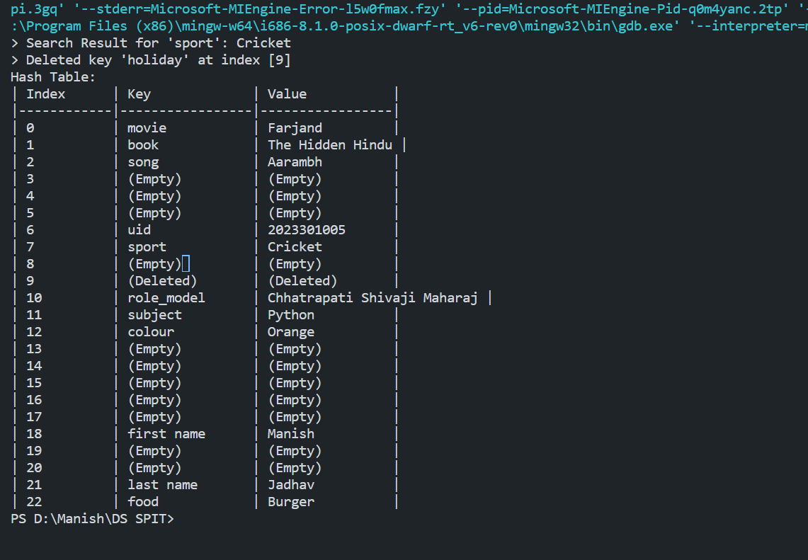

**Algorithm:**

**1. KeyValue Structure:**

- Contains a key (string), value (string), and a boolean flag to indicate if the entry has been deleted.

**2. HashTable Structure:**

- An array of pointers to KeyValue structures.

- Size of the array (`size`), load factor, number of keys (`num_keys`), number of occupied indices (`num_occupied_indices`), and number of operations (`num_ops`) are tracked.

**Functions:**

**1. createKeyValue:**

- Dynamically allocates memory for a new KeyValue structure and initializes its fields.

**2. createHashTable:**

- Dynamically allocates memory for a new HashTable structure and initializes its fields.

- Initializes the array of KeyValue pointers to `NULL`.

**3. key_to_int:**

- Converts a string key to an integer value.

**4. hash_function:**

- Uses the key_to_int function to calculate the hash index for a given key.

**5. insert_key_value:**

- Inserts a key-value pair into the hash table using quadratic probing for collision resolution.

**6. search_key:**

- Searches for a key in the hash table and returns its corresponding value.

**7. delete_key:**

- Deletes a key from the hash table and marks it as deleted.

**8. get_load_factor:**

- Calculates and returns the load factor of the hash table.

**9. get_avg_probes:**

- Calculates and returns the average number of probes per operation.

**10. display:**

- Displays the contents of the hash table

**11. Main Function:**

- Creates a hash table using `createHashTable`.

- Inserts several key-value pairs into the hash table using `insert_key_value`.

- Searches for the value of a specific key using `search_key`.

- Deletes a specific key using `delete_key`.

- Displays the contents of the hash table using `display`.

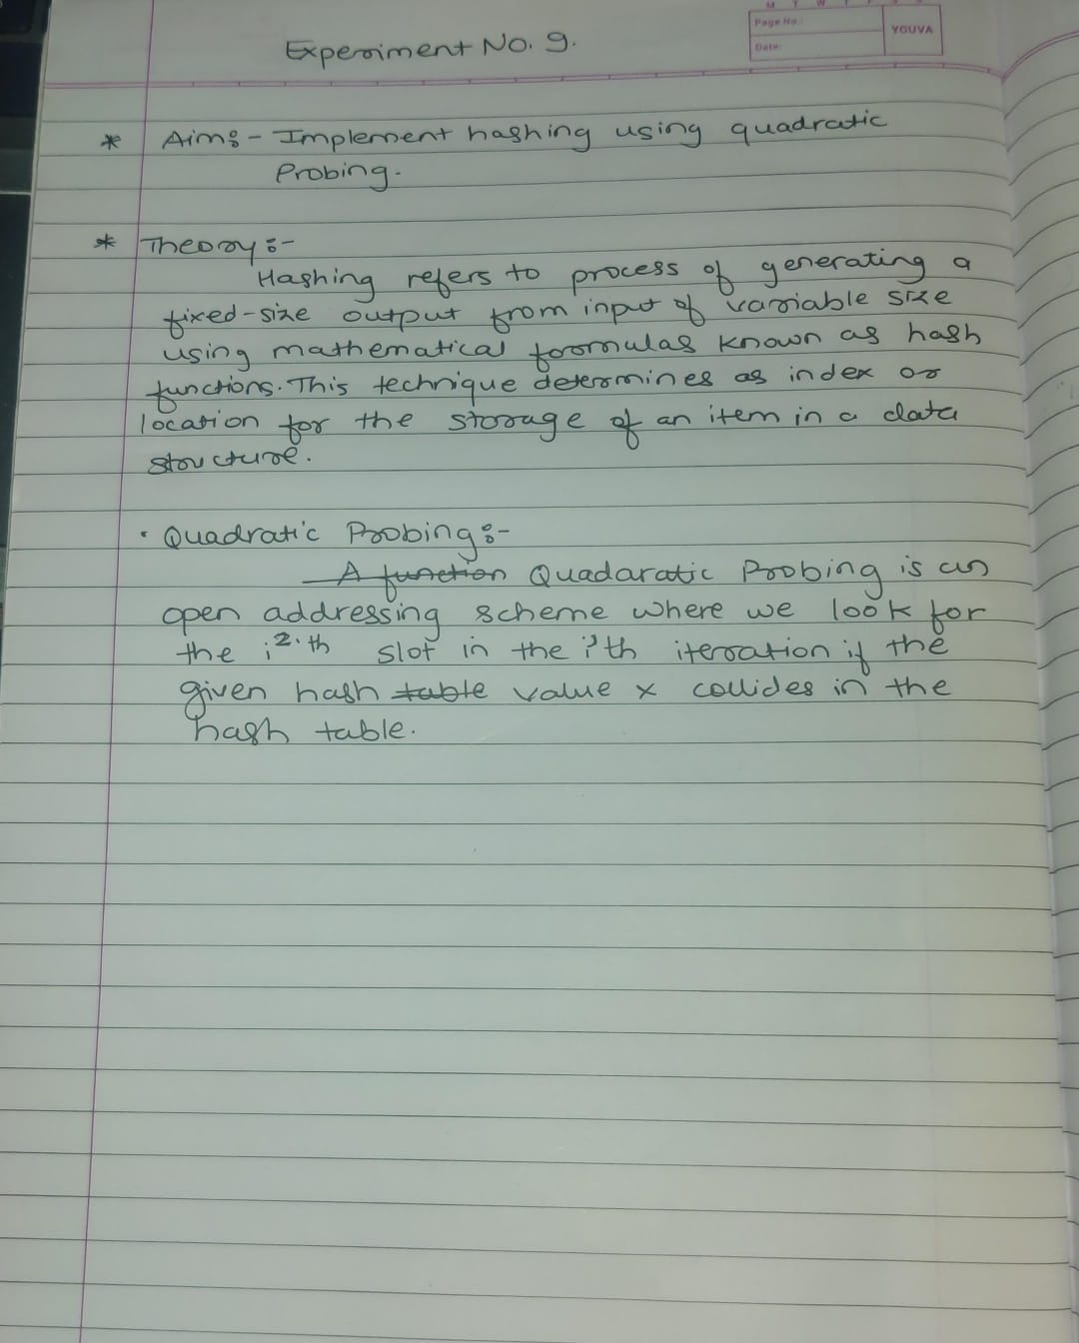

**Conclusion:**

Hence, by completing this experiment I came to know about implementing Hashing using Quadratic Probing.